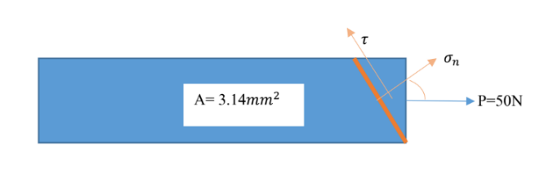1.

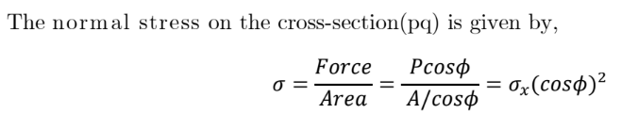

= (50/(3.14x10-6))cos220°

= **14.0608MPa**

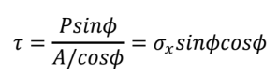

= (50/(3.14x10-4))cos20sin20

= **5.11773MPa**

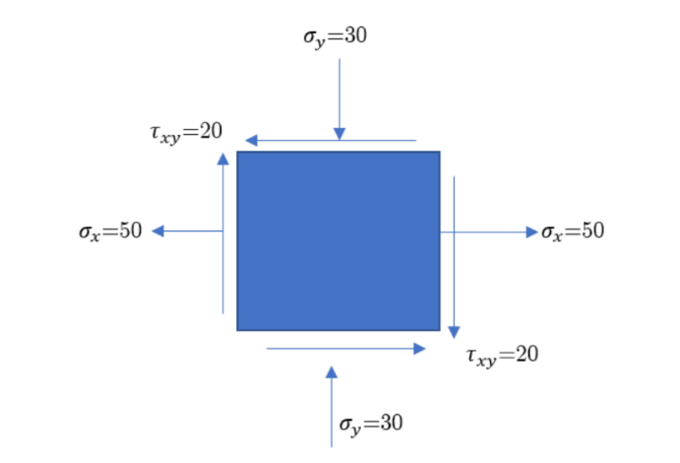2.



(a)

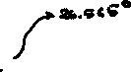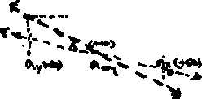

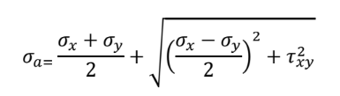

(b) Maximum principal stress

= ((50-30)/2) + (√((50+30)/2)2 + 202)

= 10+44.721 = **54.721**

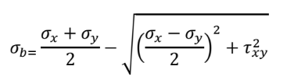

Minimum principal stress

= 10 – 44.721 = **-34.721**

Maximum shear stress = Radius of circle = **44.721**

Also, tan2θ = 20/40 = 0.5

**∴θ = tan-10.5/2**

**= 26.565/2**

**= 13.2825°**

(c)At φ=10°, σX’ = σavg + Rcos(26.565-20)[From Mohrs Circle]

= 10 + 44.4278

= **54.4278**

σY’ = σavg – Rcos(26.565-20)

= **-34.4278**

τ = Rsin(26.565-20)

= 44.721x0.11433

= **5.113**

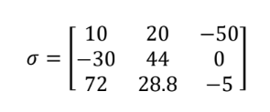3.

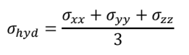

We know

= (10+44-5)/3

= **16.333**

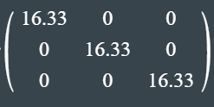

Which can be written as =



Also,

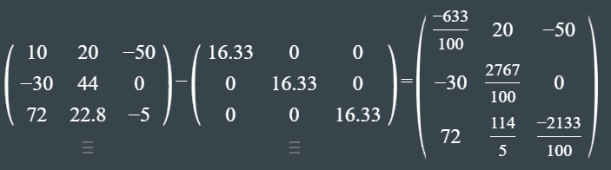



=

4.

**Isotropic Materials**: Since Cij = Cji, the stiffness tensor becomes a symmetric matrix, hence reducing the number of independent components required in the C matrix from 4 to **2**.

**Anisotropic Materials**: Canisotropic has **3** independent elements. (Less symmetry than isotropic materials)

**Orthotropic Materials**: Corthotropic has **9** independent elements. (Less symmetry than anisotropic materials)

5.

(a) My weight = 54 kgwt. = 529.2N (Assuming g = 9.8 ms-2)

(b)The weight experienced by each slipper = 529.2/2

= 264.6N

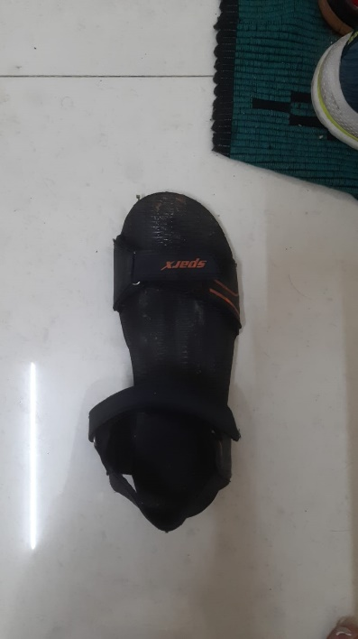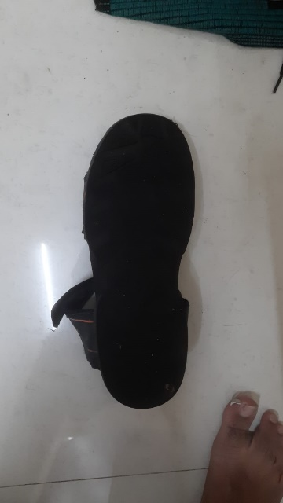(c)

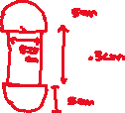

Approximate area of slipper = (πx52 + 8.75x17.3)cm2

= 229.9 cm2 = 0.02299 m2

(d) The approximate Youngs Modulus of the material we assume it to be made of (tanned leather) = **51MPa**



(e)Stress in the slippers = (Weight per slipper)/(Area of slipper)

= 264.6/0.02299

= **11.5094kPa**